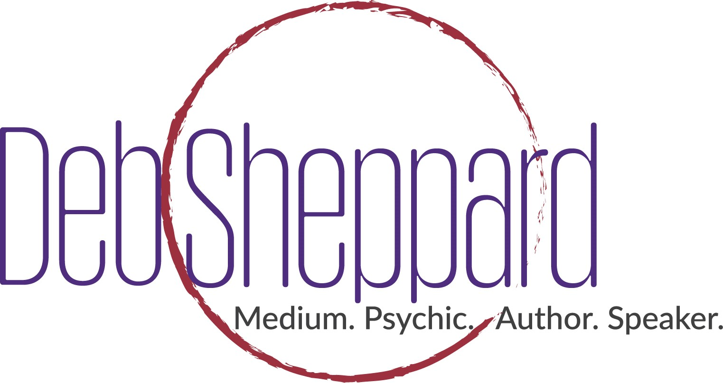
  - World-Renowned Medium & Author Deb Sheppard Announces Sacramento Show on January 19th
  - Sheppard’s Sacramento Show is one of many stops on her “Forever Connected Tour”.
Denver, Colo., January 9, 2019 –Unity of Sacramento plays host to Deb Sheppard for, “An Afternoon of Spirit Messages.” Originally from Sacramento but now residing in Denver, Deb Sheppard, medium and author of Amazon international best seller Grieving to Believing, will deliver messages from the “other” side to members of the audience for a riveting evening of laughter and love from 4:00 – 6:30 p.m. on January 19, 2019.
Deb Sheppard is a well-known medium who has a passionate belief in the afterlife and that the soul remains. During the January 19th event, audience members will get a sneak peek at life-after-death when Deb delivers messages from family members who have passed on.

See Deb’s work in these TV appearances:
- Nationally syndicated show Daily Blast Live
- Colorado & Co.

This live performance will prove electrifying to the audience. Deb Sheppard has been tested and proven to be 3% most accurate in her profession. She has appeared on numerous radio and TV talk shows and newscasts.

VIP ticket holders will enjoy access to a special after event that includes a 30-minute question and answer session with Deb. Also scheduled is a chance to meet Deb for an exclusive meet and greet.

“Our loved ones are all around us,” says Sheppard. “Their energy continues after they have crossed over. They continue to love us and want to encourage us throughout our lives. I am in awe of this amazing opportunity to share messages for so many across the country as part of my Forever Connected Tour.”

An Afternoon of Spirit Messages
With Deb Sheppard
January 19, 2019
4 – 6:30 p.m.

Unity of Sacramento

9249 Folsom Boulevard

Sacramento, Calif.

For tickets, visit https://www.debsheppard.com/events/sacramento-an-afternoon-of-spirit-messages-with-deb-sheppard/

About Deb Sheppard –Deb Sheppard, internationally recognized medium, psychic, author and speaker, has connected thousands of clients to their loved ones in spirit, helping bring life full circle. Death is a part of every life, and Deb believes those who have crossed over remain connected to us––although they are on the other side, they are forever by our side. Analysis of Deb’s incredible ability places her in the top 3% most accurate in her profession and is recommended by James Van Praagh. She is also listed in the Best Psychic Directory as a top-rated medium. Deb has been a regular guest on numerous radio shows and television stations. Through her work, Deb is a big supporter of AFSP – American Foundation of Suicide Prevention.

For more information, call 720-315-5235 or visit www.debsheppard.com

