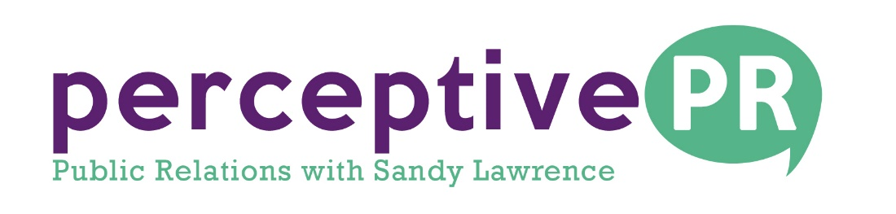

FOR IMMEDIATE RELEASE
sandy@perceptivepublicrelations.com
281.989.8892 – Cell
September 2018
INTERNATIONALLY RECOGNIZED MEDIUM, AUTHOR AND SPEAKER, DEB SHEPPARD, TO APPEAR IN DENVER ON SEPTEMBER 30TH
Be ready for an event filled with laughter, love, answers, and spirit connections at “An Afternoon of Spirit Messages with Deb Sheppard”
Denver, CO. Deb Sheppard, renowned spiritual medium who enjoys connecting clients with their loved ones in spirit, will host “An Afternoon of Spirit Messages with Deb Sheppard.”
The event is slated for September 30th from 4-6 p.m. at Unity Spiritual Center Denver, 3021 South University Boulevard in Denver, Colorado. Sheppard will deliver messages from the other side to members of the audience, proving to all that there is life after death.
Sheppard invites guests to ask their most weighty questions about life, love and the afterlife in this intimate, safe setting.
Preferred VIP Admission for Sheppard’s appearance includes front of house seating and welcome pack with a copy of Deb’s new book, Grieving to Believing-Discovering the Afterlife.
After the show, there will be a Mingle with the Medium meet and greet as well as a book signing for all who have a copy.
In Sheppard’s book, In Grieving to Believing, readers get acquainted with her personal journey of loss and healing, while also making the connections to the afterlife. The loss in her life didn’t stop her human emotions and hurt, just as others feel when death crosses their path.
James Van Praagh, clairvoyant, spiritual medium and author of the New York Times bestseller, Talking to Heaven, said about Sheppard, “I am often introduced to many so-called mediums, intuitives and psychics. There is nothing ‘so-called’ about Deb Sheppard. She is the real thing. Not only is she a very gifted talented intuitive, psychic and spiritual medium, she has an incredible amount of compassion, which is what this work is all about. I am very, very impressed with her skills, gifts and ability to connect with her audiences.”
To register for the September 30th event, go to https://www.debsheppard.com/events/denver-an-afternoon-of-spirit-messages-with-deb-sheppard.
For more information on ordering Sheppard’s book or to see her upcoming personal appearances, go to www.debsheppard.com.
ABOUT DEB SHEPPARD:
Deb Sheppard, internationally recognized medium, psychic, author and speaker, connects thousands of clients to their loved ones in spirit, helping bring life full circle. Death is a part of every life, and Deb believes those who have crossed over remain connected to us––although they are on the other side, they are forever by our side.
Deb’s incredible ability places her in the top three percent most accurate in her profession and is known in her work as an “empath” and medium. As an entertainer, her sense of humor, light-heartedness and compassion create a safe and fun environment for all who attend her readings and events.
Several publications have highlighted her philosophies and spiritual understandings, including The Healing Path Magazine, which also featured John Holland; Orbs A Personal Journey, a book by Donna Didomenico; Good to Go: A Guide to Preparing for End of Life, by Jo Myers; and My Loved One Shines On, a Gift from Beyond, by Disa Van Orman.
Deb has been the featured speaker on the topic of suicide for multiple organizations and at numerous events, such as the Young Professionals Organization, Survivors of Suicide, Women in Business with Mrs. Sandy Dahl (widow of Captain Jason Dahl, the pilot of United Airlines flight 93 on 9/11), and at Cherokee Castle & Ranch in Sedalia, Colorado.
She takes part in other organizations doing good work in the world, too, including the “Chelsea Hutchison Foundation,” which benefits families touched by seizures. Deb has been involved with Denver Hospice’s “The Mask Project,” “Camp Comfort” and “Project Safeguard.”
Filled with enthusiasm for helping others, Deb facilitates self-discovery through her Mentoring Program. She also participates in the community by mentoring intuitive kids and supporting teachers and school counselors through her program, “The No Labels Project.”
###

