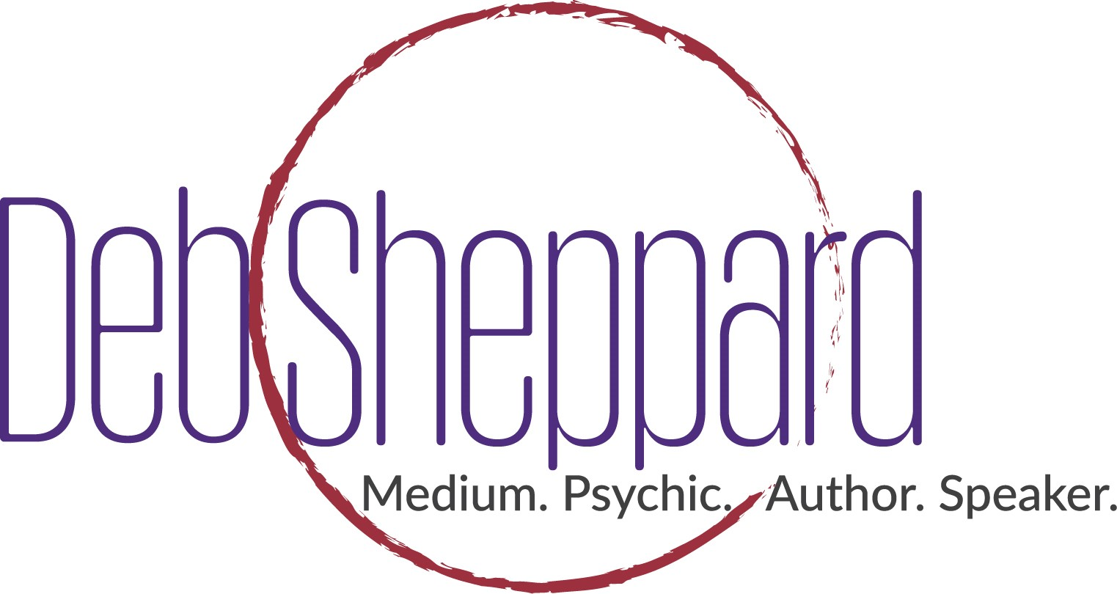

Two Powerhouse Mediums to Share Stories of Afterlife in Denver
  - Denver-based medium Deb Sheppard and world-famous medium James Van Praagh to take the stage together at the Inverness Hotel.
Denver, Colo., February 25, 2018 – The Hilton Denver Inverness plays host to two of the world’s renowned mediums for, “An Afternoon of Spirit Messages.” Denver-based medium Deb Sheppard and famed medium James Van Praagh share the stage on February 25, 2018, and will deliver messages from the “other” side to members of the audience for a riveting afternoon of laughter and love.
VIP ticket holders will enjoy access to a special after event that includes a 30-minute question and answer session with Deb and James. Also scheduled is a chance to meet both James and Deb as well as a book signing.

Both Deb and James are well-known mediums who share a passionate belief in the afterlife and that the soul remains despite the body’s demise. During the February 25th event, audience members will get a sneak peek at life-after-death when Deb and James deliver messages from family members who have passed on.

This live performance will prove electrifying to the audience. Deb Sheppard has been tested and proved to be 3% most accurate in her profession. James Van Praagh is legendary in this field and has been seen on such shows as Oprah, Dr. Phil, Larry King Live, 20/20, The View, The Today Show, Chelsea Lately, Beyond Belief, Biography, Coast to Coast, 48 Hours, and a multitude of others. He’s also a prolific author with many appearing on the New York Times Best Selling list.

“Our loved ones are all around us,” says Sheppard. “Their energy continues after they have crossed over. They continue to love us and want to encourage us throughout our lives. I am in awe of this amazing opportunity to share messages for so many across the country as part of my Forever Connected Tour.”

An Afternoon of Spirit Messages
With James Van Praagh and Deb Sheppard
February 25, 2018
2 – 4 p.m.
Hilton Denver Inverness

200 Inverness Drive West

Englewood, CO

For tickets, go to spiritmessagesdenver.eventbrite.com

About Deb Sheppard –Deb Sheppard, internationally recognized medium, psychic, author and speaker, has connected thousands of clients to their loved ones in spirit, helping bring life full circle. Death is a part of every life, and Deb believes those who have crossed over remain connected to us––although they are on the other side, they are forever by our side. Analysis of Deb’s incredible ability places her in the top 3% most accurate in her profession and is recommended by James Van Praagh. She is also listed in the Best Psychic Directory as a top-rated medium. Deb has been a regular guest on numerous radio shows and television stations. Through her work, Deb is a big supporter of AFSP – American Foundation of Suicide Prevention.

For more information, call 720-315-5235 or visit www.debsheppard.com

