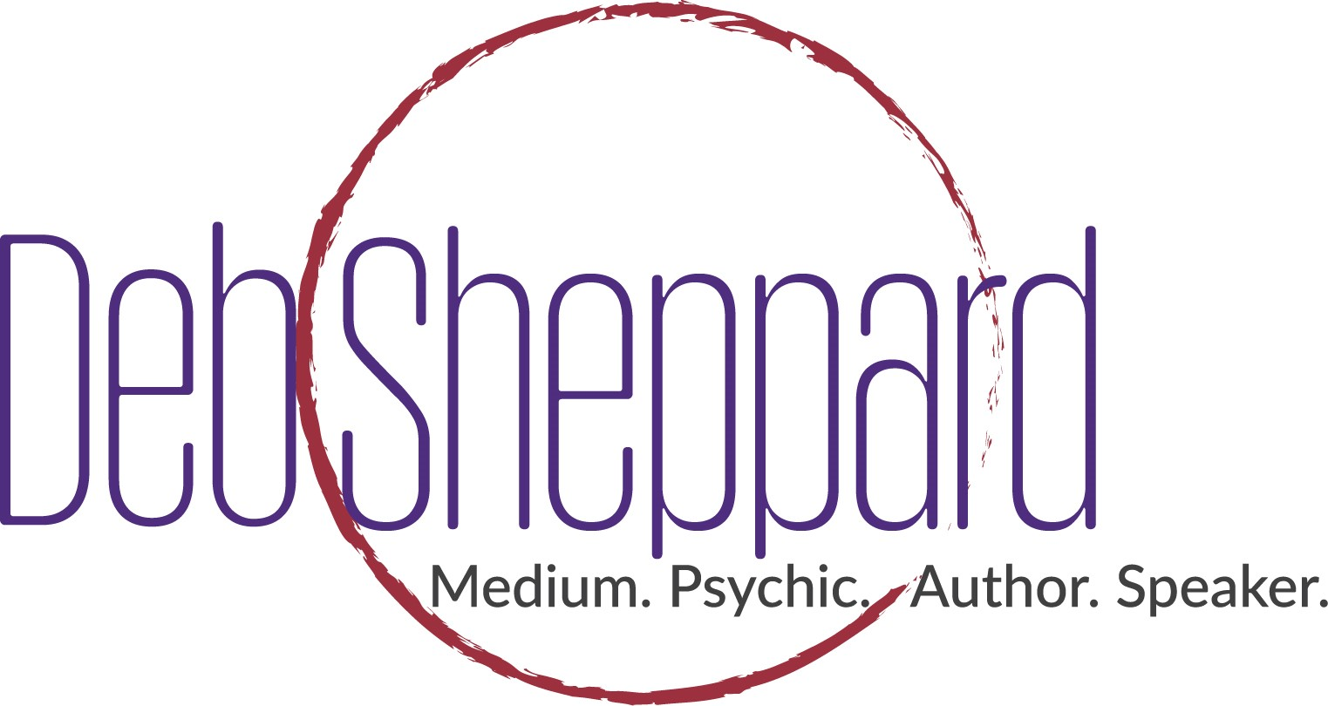

World-Renowned Medium Deb Sheppard takes the CU South Campus Stage in Lone Tree, Colo. on October 20th, 2017
  - Sheppard’s Denver Co Show is one of many stops on her “Forever Connected Tour”.
TICKETS GO ON SALE – September 26, 2017.
Denver Colorado (September 27, 2017)- CU South Campus in Lone Tree is proud to announce the appearance of Deb Sheppard, world-renowned medium, psychic, author and speaker on October, 20, 2017. Tickets for this electrifying and emotional event go September 26th and can be purchased at https://www.eventbrite.com/e/denver-forever-connected-deb-sheppard-live-tickets-37955950269. Tickets start at $39.00 (plus applicable service charges) and are subject to change. Purchasing a ticket does not guarantee a reading.
CU South Campus is located in the previous Wildlife Experience location. This is a beautiful theater style seating venue in which everyone will be able to see the stage. The address is 10035 S Peoria St, Parker, CO 80134.
Deb Sheppard’s live performance is electrifying and one that you won’t soon forget. Through Deb’s amazing ability to connect with loved ones who have passed on, she provides a conduit between the audience and the spirit world. You will be astounded as Deb reveals secrets only family members would know. It’s a mind-bending and emotional evening.

“Because this can be such a moving experience, I like to combine my humor as I communicate with those on the other side,” says Sheppard. “I want everyone to have a good time because there is a lot of emotion that pours forth as people communicate with those who have passed on.”

See Deb in action in this short video.

Deb firmly believes that everyone is “Forever Connected” with their family and has helped thousands with their journey into understanding life, loss and living a life they desire to create.

“Our loved ones are all around us,” says Sheppard. “Their energy continues after they have crossed over. They continue to love us and want to encourage us throughout our lives. I am in awe of this amazing opportunity to share messages for so many across the country as part of my Forever Connected Tour.”

Tickets are available by purchasing here: https://www.eventbrite.com/e/denver-forever-connected-deb-sheppard-live-tickets-37955950269

About Deb Sheppard –Deb Sheppard, internationally recognized medium, psychic, author and speaker, has connected thousands of clients to their loved ones in spirit, helping bring life full circle. Death is a part of every life, and Deb believes those who have crossed over remain connected to us––although they are on the other side, they are forever by our side. Analysis of Deb’s incredible ability places her in the top 3% most accurate in her profession and is recommended by James Van Praagh. She is also listed in the Best Psychic Directory as a top-rated medium. Deb has been a regular guest on numerous radio shows and television stations. Through her work, Deb is a big supporter of AFSP – American Foundation of Suicide Prevention.

For more information, call 720-315-5235 or visit www.debsheppard.com

