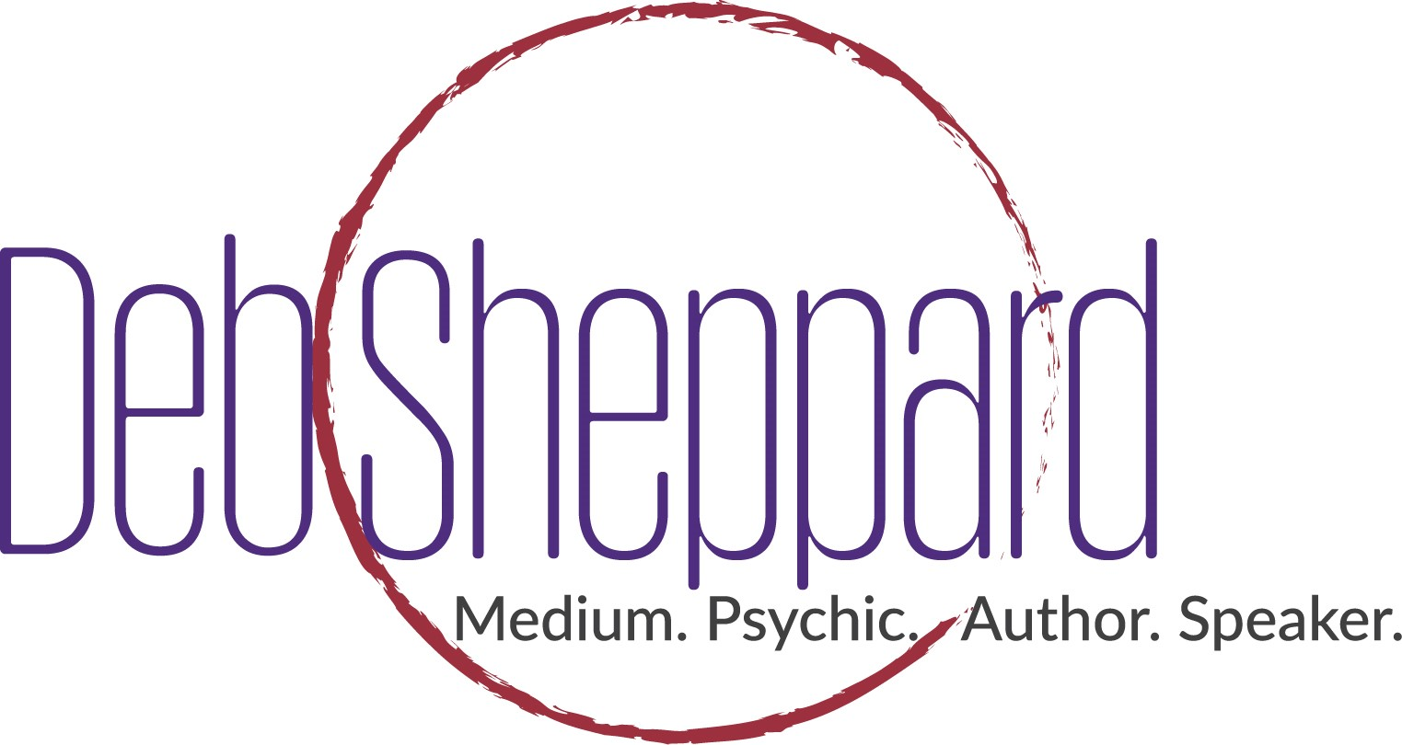

World-Renowned Medium Deb Sheppard takes the Sandia Resort and Casino Grand Ballroom Stage on November 17th, 2017.
  - Sheppard’s (Albuquerque New Mexico Show is one of many stops on her “Forever Connected Tour”.
TICKETS GO ON SALE – September 26, 2017.
Albuquerque NM. September 26, 2017 – Sandia Resort and Casino is proud to announce the appearance of Deb Sheppard, world-renowned medium, psychic, author and speaker on November 17th, 2017. Tickets for this electrifying and emotional event go on-sale September 26th, 2017 and can be purchased at Ticketmaster.com, or the Sandia Resort and Casino box office. Tickets start at $35.00 (plus applicable service charges) and are subject to change. Purchasing a ticket does not guarantee a reading.
Deb Sheppard’s live performance is electrifying and one that you won’t soon forget. Through Deb’s amazing ability to connect with loved ones who have passed on, she provides a conduit between the audience and the spirit world. You will be astounded as Deb reveals secrets only family members would know. It’s a mind-bending and emotional evening.

“Because this can be such a moving experience, I like to combine my humor as I communicate with those on the other side,” says Sheppard. “I want everyone to have a good time because there is a lot of emotion that pours forth as people communicate with those who have passed on.”

See Deb in action in this short video.

Deb firmly believes that everyone is “Forever Connected” with their family and has helped thousands with their journey into understanding life, loss and living a life they desire to create.

“Our loved ones are all around us,” says Sheppard. “Their energy continues after they have crossed over. They continue to love us and want to encourage us throughout our lives. I am in awe of this amazing opportunity to share messages for so many across the country as part of my Forever Connected Tour.”

Tickets are available by Ticketmaster.com, search Deb Sheppard or the Box office at Sandia Resort and Casino.

About Deb Sheppard –Deb Sheppard, internationally recognized medium, psychic, author and speaker, has connected thousands of clients to their loved ones in spirit, helping bring life full circle. Death is a part of every life, and Deb believes those who have crossed over remain connected to us––although they are on the other side, they are forever by our side. Analysis of Deb’s incredible ability places her in the top 3% most accurate in her profession and is recommended by James Van Praagh. She is also listed in the Best Psychic Directory as a top-rated medium. Deb has been a regular guest on numerous radio shows and television stations. Through her work, Deb is a big supporter of AFSP – American Foundation of Suicide Prevention.

For more information, call 720-315-5235 or visit www.debsheppard.com

Sandia Resort and Casino
30 Rainbow Rd NE
Albuquerque, NM 87113

